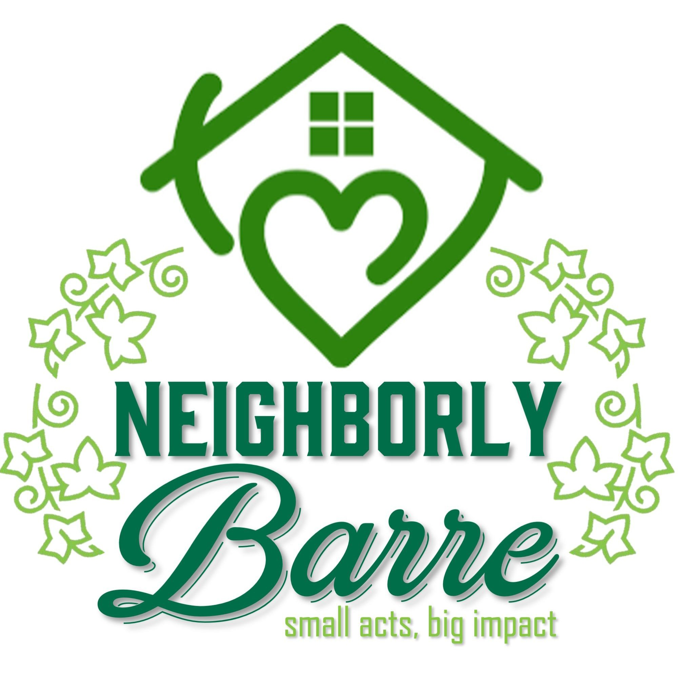Minutes of meeting of The Neighborly Barre Committee
Monday, October 5, 2026 in Roosevelt Room Alumni Hall

Present: Tracie Lewis, Beth Hilgartner, Ernie Drown, Joanne Reynolds, Marjorie Strong
Not Present: MiChelle Brown
Guests: No Guests

Called to order at 1:03 pm. Agenda approved.
Minutes approved.

No visitors or communications. Old business:
-Cider and donuts event was a success. Lots of visitors.
-Walking tour was a success. Good turnout, about 28. Discussion.
-Orange St. student event….decided to let it go till next year. Maybe talk to the school about a wider event.

New business:

-Cemetery stone cleaning event. Tracie went to Granite City 5K. Star Lecompte has someone
who might give a large donation for cleaning and repair through a non-profit…Barre Partnership. Beth talked to Matt Peake, (private cleaning contractor) who mentions liability concerns with power washer. He did think simple washing would be ok. Trash pickup and plantings maintenance would be nice. Discussion about the inaccurate ‘no dogs’ sign. Collaborate with the veterans who do the flags on holidays? Wide-ranging discussion. Ghost walk in the cemetery? Collaborate with the cemetery committee? Action deferred till next meeting.
-Should we be part of the hot cocoa holiday welcome events, held 11 to 1 on Saturdays between
Thanksgiving and Christmas in Depot Square? Decision deferred to next meeting. Listening events by Ward, opportunities for residents to talk about their concerns. General agreement that this was not our remit, but a few “meet your councilor” sessions hosted by us at the Library seemed worth pursuing. No action taken.
-Beth sent an email to Tracie and the Partnership about getting more involvement with council meeting concerns. NBC and Partnership social media might be used for highlights of council meetings.

Miscellaneous matters.
-Ernie brought up making a list of the surviving social clubs, service clubs. Lions, Boy Scouts, VFW, etc., with the aims of getting all that info in one place and pursuing reciprocal cooperation.

Meeting adjourned at 1:58. Next mtg 11/2 at 1pm.

NEIGHBORLY BARRE COMMITTEE VISION STATEMENT
(from City’s website)
The City Council created a Neighborly Barre Committee, and charged it with generating ideas and enthusiasm for volunteer-driven efforts to create community, build connections and engagement among residents, and boost simple projects (like picking litter, or "adopting" a bus stop) to beautify and care for our physical spaces. The Committee's role will be to generate ideas that provide opportunities for residents of all ages to come together to model the type of community we want to be; to collaborate with other organizations or committees (eg. The Barre Partnership, the Barre Rivers Collective etc.) when projects overlap; and to encourage resident engagement in the City, its people, and its businesses and organizations.

The committee will initiate programs and products based on needs, including the unhoused, civic beautification and building social capital. A welcoming Barre where neighbors feel connected, supported, and proud to call our community home.

GUIDING PRINCIPLES Welcoming First
We believe everyone deserves to feel seen, included, and at home in Barre, whether they are new to the community or have lived here for generations.

Connection Builds Community
Strong relationships are the foundation of a thriving city. We create opportunities for meaningful, low-pressure connections among neighbors.

Inclusive & Accessible
We strive to design programs and initiatives that are accessible, inclusive, and reflective of Barre’s diverse residents, backgrounds, and experiences.

Community-Driven
Our work is guided by the voices, needs, and ideas of the community. Collaborate, promote & support other community committees and organizations to facilitate support of programs already in motion.

Positive & Neighborly
We lead with kindness, respect, and optimism, fostering a culture of care and mutual support throughout Barre.

Building Social Capital
We foster trust, relationships, and shared experiences that strengthen social networks, encourage civic engagement, and build a more resilient Barre.

Pride in Place
We celebrate Barre’s people, neighborhoods, and shared spaces, encouraging community pride and a sense of belonging.

